

Contents

Registering for WeCare 3

Inputting a New WeCare 4

Task Assigning for the WeCare Manager 7

Task Manager/Sub assignment 8

Dashboard 10

Run a Report: 13

|  |
| --- |
| Registering for WeCare |
| * In your browser, type in **fdotwecare.com** * Click “Register as a new user” |



|  |
| --- |
| * Enter your FDOT email * Create your password   + (The default password configuration is a minimum of 7 characters, which must include one numeric and one non-alphanumeric character. Your password needs to be less than 10 characters. Example: WeCare297* * Re-enter your password to Confirm password * Click “Register” |

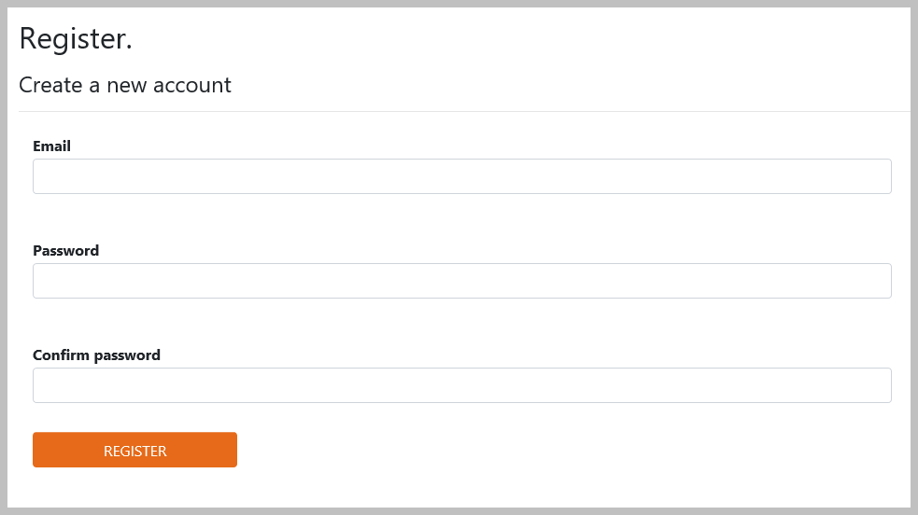

|  |
| --- |
| Inputting a New WeCare |



|  |
| --- |
| * Enter your FDOT email * Enter your password * Click “Login­­­­” |
| * To input a new WeCare ticket, enter as much information as the customer will give you.   + If the customer chooses to remain anonymous, you do not need to include any contact information.   + If the customer does not want to be contacted within 24 hours, uncheck “Requirement to contact customer.” |

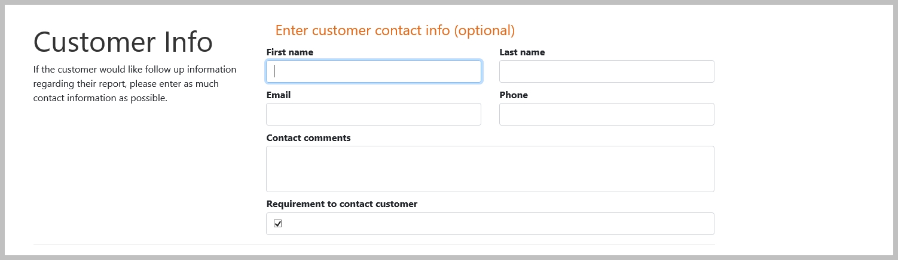

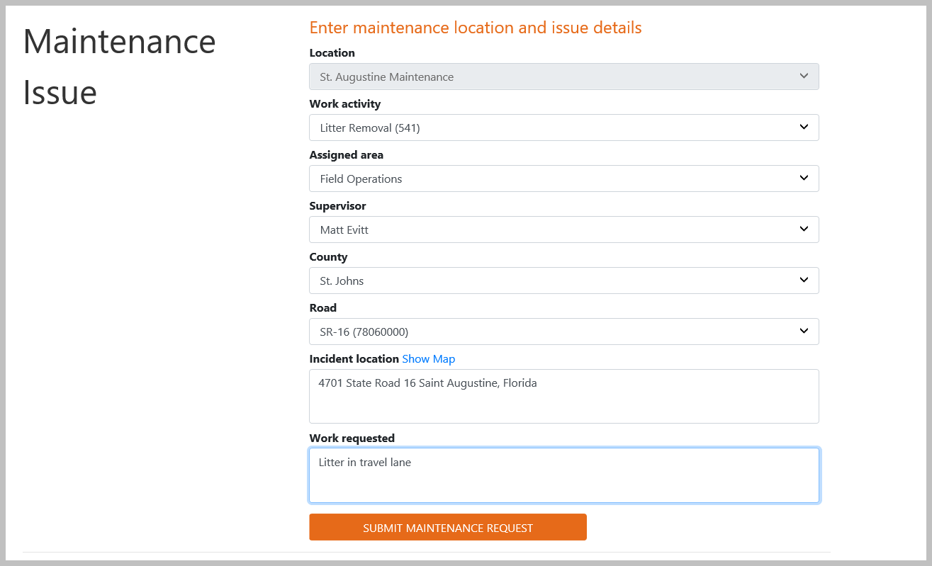

|  |
| --- |
| * Choose an activity from the “Work Activity” dropdown menu |

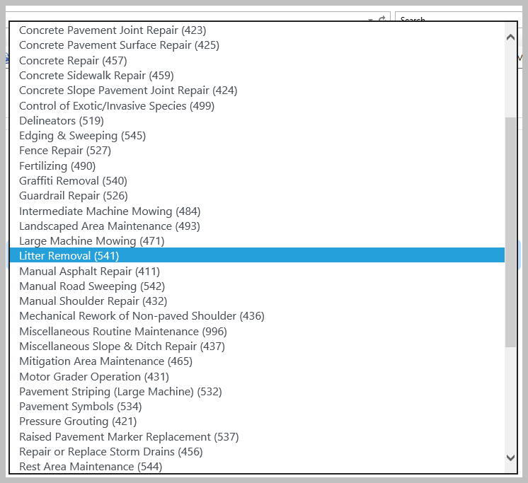

|  |
| --- |
| * Choose an area from the “Assigned Area” dropdown menu |

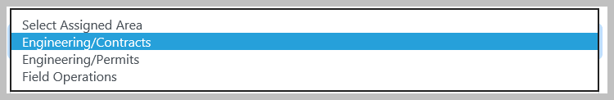

|  |
| --- |
| * Choose a name from the “Supervisor” dropdown menu   + When you choose the Assigned Area, the system will automatically populate the Supervisors for that area   + (In Cost Center 297, Ian Middlemas is the back up to all Supervisors. If a Supervisor is on vacation or out sick, choose Ian Middlemas) |

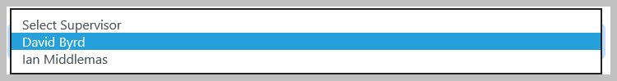

|  |
| --- |
| * Choose the county from the “County” dropdown menu |

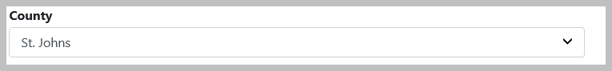

|  |
| --- |
| * Choose the road name from the “Select Road” dropdown menu |

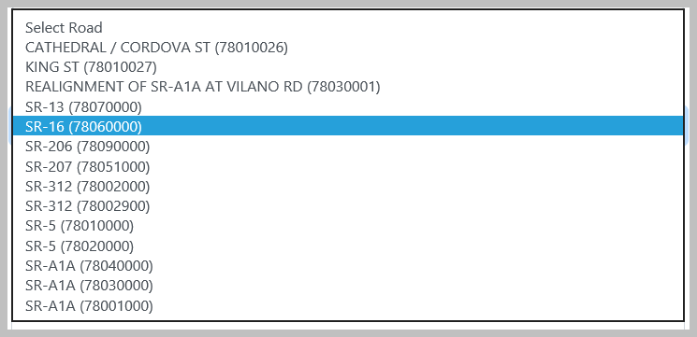

|  |
| --- |
| * Enter the address or intersection of the WeCare incident in the “Incident Location” textbox * Include the City and State for the map to properly function   The mapping function will not work if you put other information in the box |

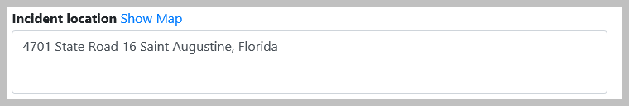

|  |
| --- |
| * Use the Work Requested textbox to type in the concern |

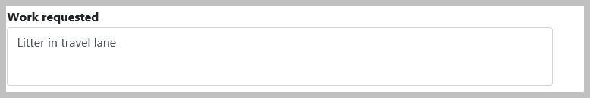

|  |
| --- |
| * When inputting a WeCare, you can upload a jpeg. * Click Upload Files * Browse and choose file to be added * Click Upload File * Currently, we have to upload one photo at a time. |

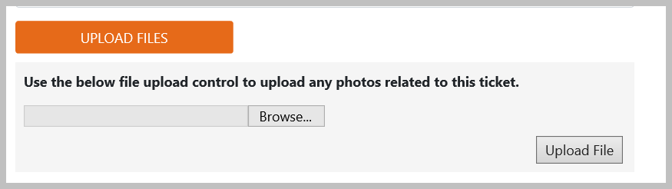

|  |
| --- |
| * Click “Submit Maintenance Request” |



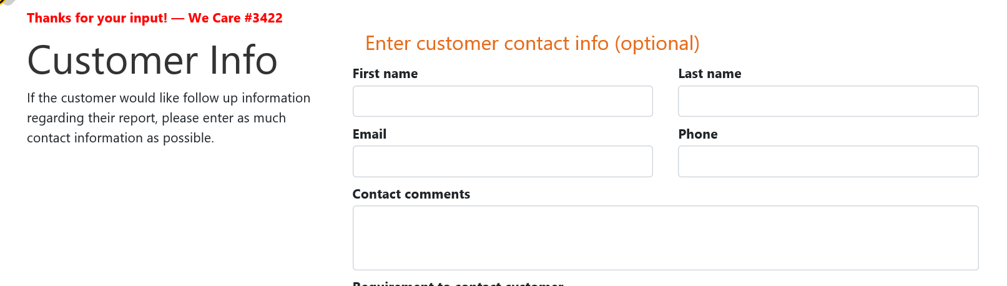

|  |
| --- |
|  |
| * Once the WeCare is submitted it will be assigned to either the AM Contractor or the WeCare Manager |
| * Logout of the system when you are done   PLEASE DO NOT JUST CLOSE THE WEB BROWSER! |



|  |
| --- |
| Task Assigning for the WeCare Manager |
| * The WeCare Manager will receive an email * Click “here” and the WeCare Ticket will open |

cid:image001.png@01D57444.53D84C20

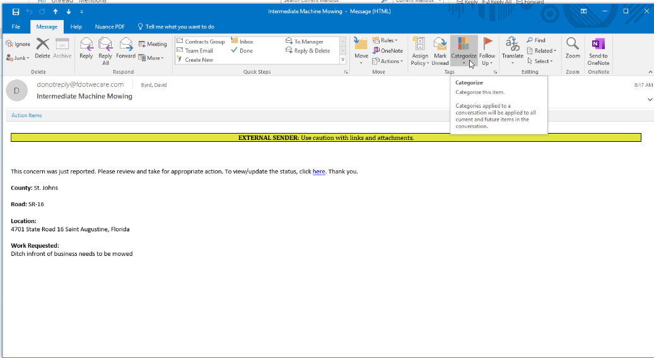

|  |
| --- |
| * The WeCare Manager will then choose the **Sub Assignment**, which is the person who will taking care of the concern. * Each of our Coordinators are assigned A, B and H agreements/contracts. If the concern has to do with a particular agreement/contract, the WeCare Manager will assign the task to that specific coordinator. |

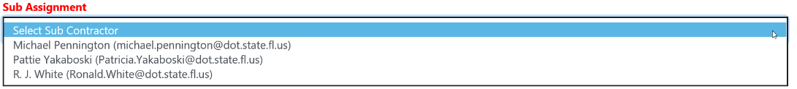

|  |
| --- |
| * Once the WeCare Manager selects a Sub Assignment, the system will update and show “**Thank you. Task Complete**.” |

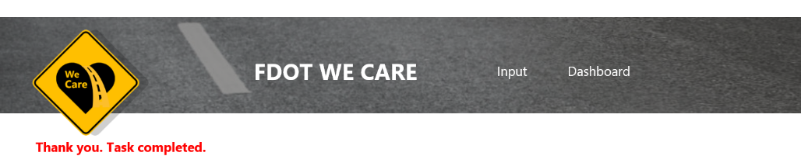

|  |
| --- |
| Task Manager/Sub assignment |
| * Whoever oversees the AM Contractor is the Task Manager or WeCare Manager (i.e. David Byrd/Contracts Manager, Nate Gottschalk/Permits Manager, or Matt Evitt/Field Ops) * They will receive and email and can open the WeCare by will clicking “here.” |

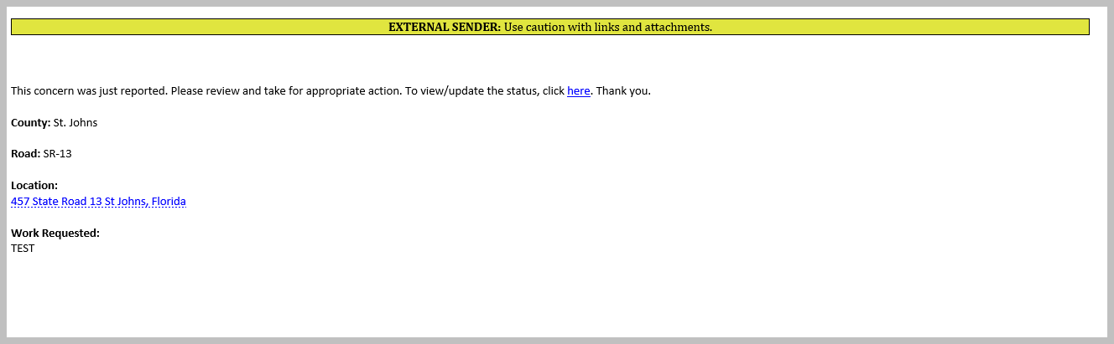

|  |
| --- |
| * When contact is made with the customer, click on the “Caller Contacted” box. This will auto populate a date and time stamp. * If you click “Show Map,” the system will generate a Google Map that can be used to generate directions to the site. |

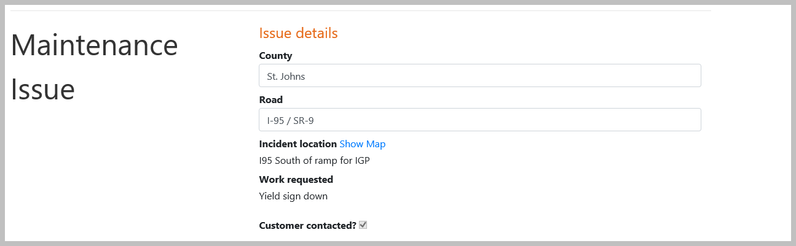

|  |
| --- |
| * When work is complete, the Task Manager will fill in the Task Manager comments * Click the “Work Completed?” box * To upload photographs, click “Browse” and select the photograph * Click “Upload File” * (You will repeat these steps for every photo) |

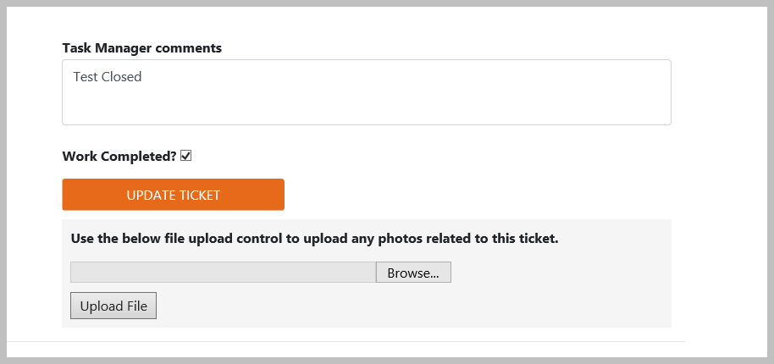

|  |
| --- |
| * Click “Update Ticket” * Once you click “Update Ticket,” it will auto populate the date and time |



|  |
| --- |
| * Click OK if the work is complete |

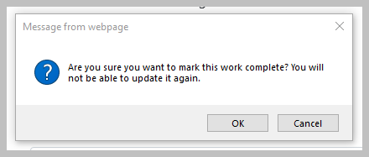

|  |
| --- |
| * The Task Manager will receive the below message. |

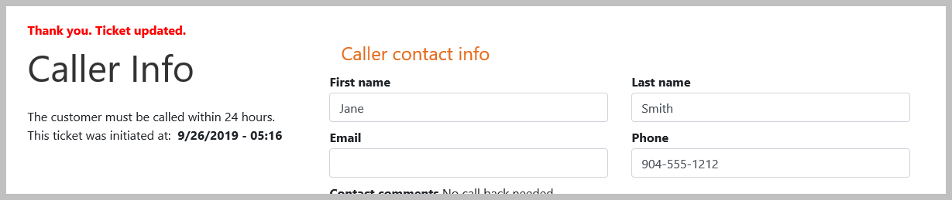

|  |
| --- |
| * An email will be then sent to the WeCare Manager. If it’s an AM Contract, the Contract Coordinator will receive the email to close the ticket. All others, the WeCare Manager will receive the email and follow the same steps. The Task Manager will receive an email and can click “here” to open the WeCare Ticket. |

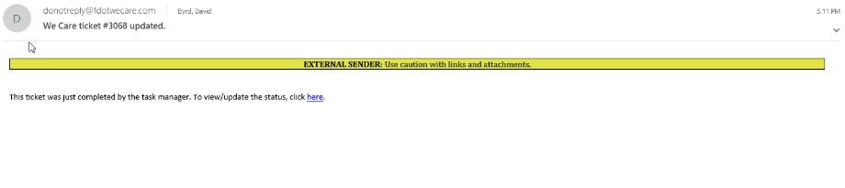

|  |
| --- |
| * Fill in the “Closer Comments,” click “Close Ticket.” * You can also browse and upload pictures (if you have any). Click “Upload File,” and then click “Update Ticket.” (Once you click Update Ticket, it will auto populate the date and time.) |

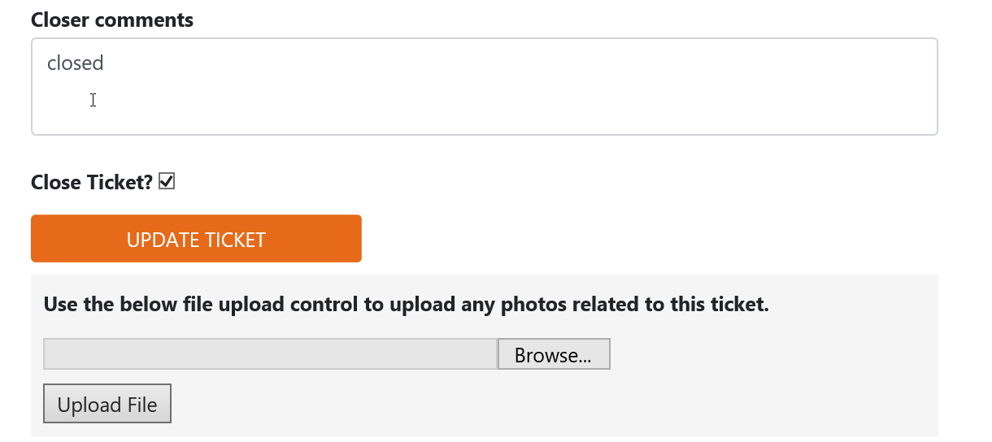

|  |
| --- |
| * The WeCare is now completely closed. |

|  |
| --- |
| Dashboard |
| Both Directors in District Office and WeCare Managers will have access to the Dashboard.   * In order to access the Dashboard, you will have to log into the WeCare System * You will be able to remind the Contractor of the 14 days, by clicking on Remind Contractor * If a WeCare goes past the 14 days, the WeCare will turn red. * There is a box labeled “Routine Maintenance.” This can be checked if it the complaint will be added on a future Maintenance Schedule or Contract. This will eliminate the system from counting the days. * You can use the “Filter” dropdown menu to filter your search * If a WeCare needs to be edited, click “Reinitialize Ticket” to make changes. The WeCare be reassigned to the person who inputted the ticket. * If a Unit puts in a WeCare and it is not in their area, you can choose the “Transfer Ticket” dropdown to select the correct Unit and it will be transferred to their office. (This can only be done once all the Units are in the system.) * Once the testing is complete, a “Print” button will appear. |
| * The “Remind Task Manager” tab will send an email reminder the person who the ticket is assigned. * This button will turn to “Remind Closer” if the Task Manager has already inputted their comments in the system, checked “Work Complete” box, and updated ticket. |

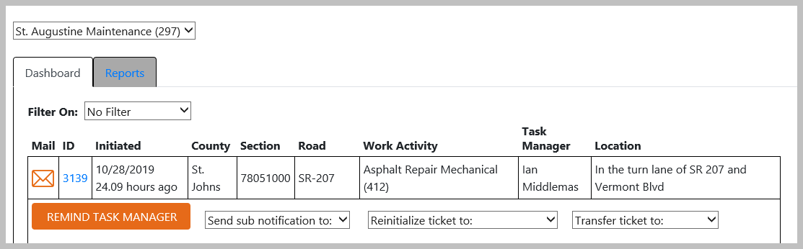

|  |
| --- |
| * If you click “Remind Closer”, an email will be sent to the closer to close out the ticket. |

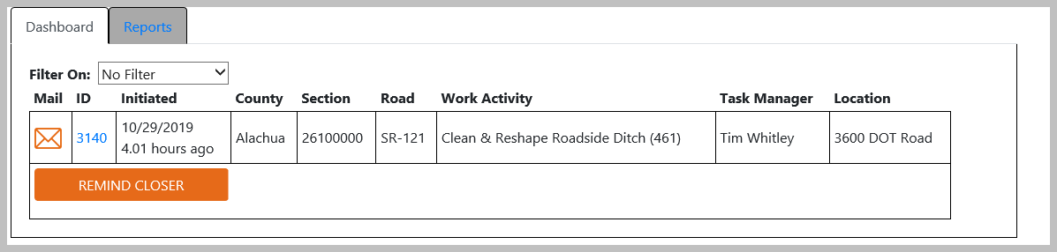

|  |
| --- |
| * To find out who the WeCare has been sent to, click the “Mail” tab. |



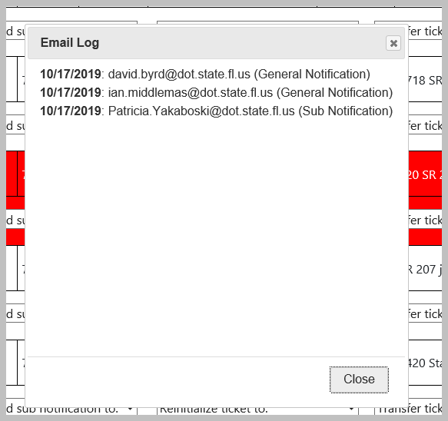

|  |
| --- |
| * The WeCare Manager can notify their sub/Task Manager (i.e. Contract Coordinators, Permits Coordinator or Field Ops Supervisor) by choosing them from the dropdown. |

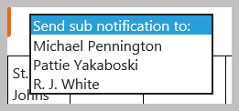

|  |
| --- |
| * To reinitialize a ticket to a different area, choose the WeCare Manager from the dropdown, and the WeCare Ticket will be transferred. |

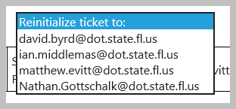

|  |
| --- |
| * If a WeCare needs to be transferred to another unit, click “Transfer Ticket” and choose area. |

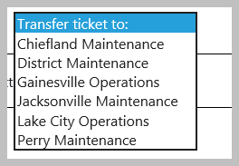

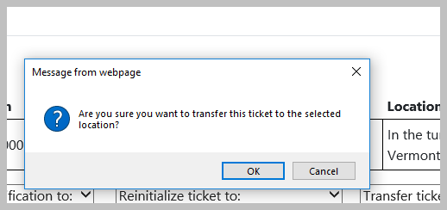

|  |
| --- |
| Run a Report:  * Select the “Reports” tab * Select the report (Choose “Report 1” until more reports are added) * Complete the fields needed to run the report * Click “Generate Report” |

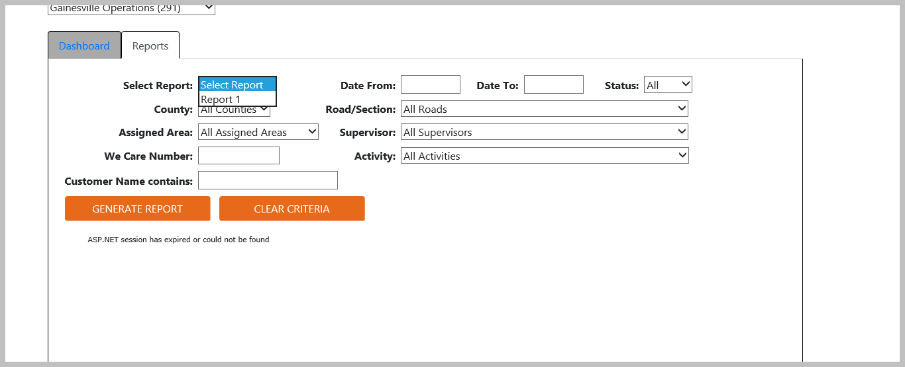

|  |
| --- |
| * When you’re done with your session, logout of the WeCare System. |

